CprE 381 – Computer Organization and

Assembly-Level Programming

Lab-04 Report

Student Name Chimzim Ogbondah

Section / Lab Time 4:10-6:00

Submit a typeset pdf version of this on Canvas by the due date. Refer to the highlighted language in the Lab-04 instructions for the context of the following questions.

- [Prelab] Based on the waveforms, provide a description in your own words of how this component operates. This can be in the form of a textual description, flow chart, or state machine

- [Part 1 (a)] What are the MIPS instructions that require some value to be sign extended? What are the MIPS instructions that require some value to be zero extended?

  - I type instructions need to be sign extended, or & and immediate need to be zero extended

- [Part 1 (b)] what are the different 16-bit to 32-bit “extender” components that would be required by a MIPS processor implementation?
  - Sign and Zero extension

- [Part 1 (d)] Waveform.
  - 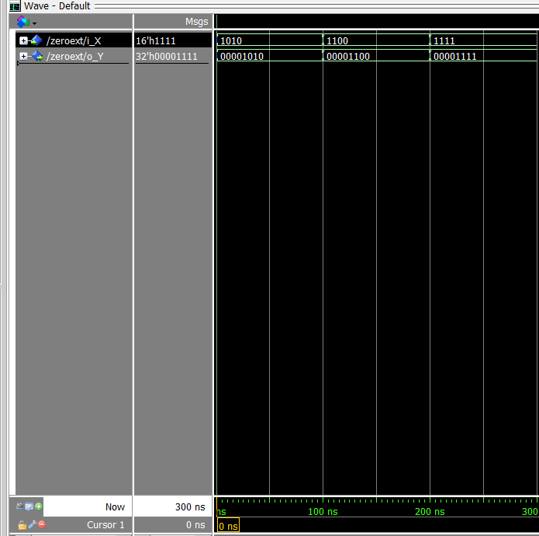
  - 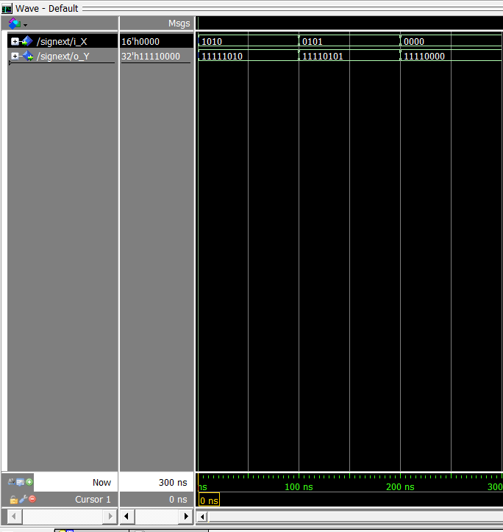

- [Part 2 (b)] Provide a 2-3 sentence description of each of the individual ports (both generic and regular).
  - Data_width: Generic port that holds the value of the data size (32)
  - Addr_width: is the length of the address in memmory
  - Clk: Acts as a clock, on the rising edge of the clock it checks to see if the write enable is high(which it always is) from there it will input the data based on the register address value it was given
  - Addr: Will dictate which address in memory is should be writing to
  - Ram: is an array of addresses that have size Data width. This is where memory is accessed and written to
  - Data: Holds the data that needs to be written to memory
  - We: is always high but acts as a check to see if the data should be written to memory
  - Q: Is of size Data_width, it holds the data that was just written into memory. However it retrieves it by calling the addr just written to in the RAM array

- [Part 2 (c)] Waveform.

- [Part 2 (d)] Briefly describe how the waveforms for this mem.vhd module differ from those that you analyzed as part of the pre-lab.

- [Part 3 (a)] what control signals will need to be added to the simple processor from Lab #3? How do these control signals correspond to the ports on the mem.vhd component analyzed in problem 2)?

- [Part 3 (b)] Draw a schematic of a simplified MIPS processor consisting only of the base components used in Lab #3, the extender component described in problem (1), and the data memory from problem (2).

- [Part 3 (c)] Waveform.

- [Feedback] You must complete this section for your lab to be graded. Write down the first response you think of; I expect it to take roughly 5 minutes (do not take more than 10 minutes).

  - How many hours did you spend on this lab?

Task | During lab time | Outside of lab time
Reading lab
Pencil/paper design
VHDL design
Assembly coding
Simulation
Debugging
Report writing
Other:
Total

  - If you could change one thing about the lab experience, what would it be? Why?

  - What was the most interesting part of the lab?

